Basic Mathematics

## Introduction

This document covers

Introduction

#### Definition

## Arithmetic

## Algebra

### Terms and Factors

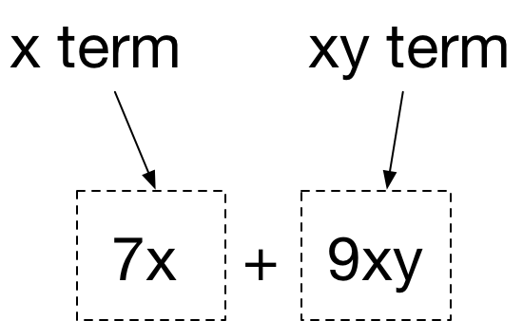

Terms with the same variable are called **like terms**. Terms that share some variables are called **similar terms.** The variables that like terms shared are called the **common factors and extracting the common factors is known as factorisation**



### Algebraic Division

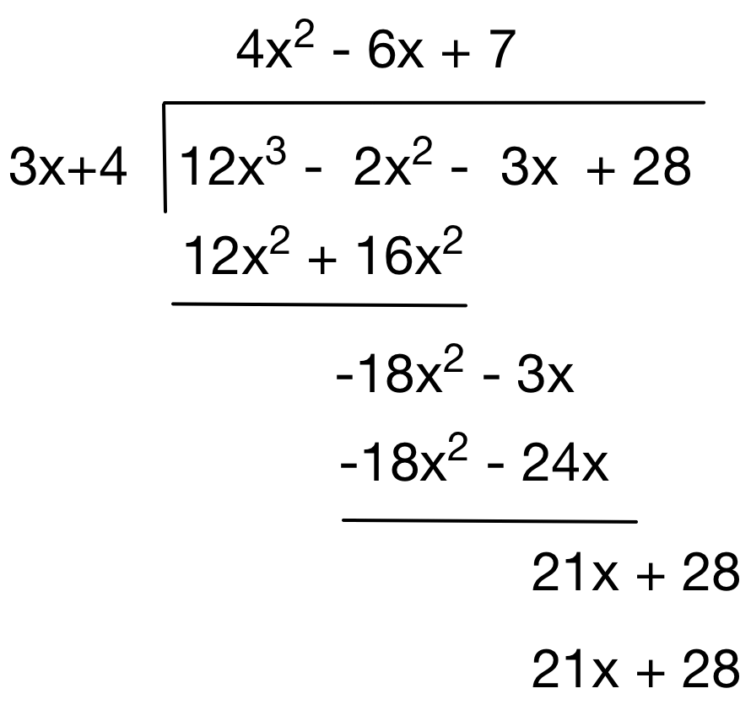

### Factorisation

#### Extract Common Factors

$$35x^{2}y^{2}-10xy^{3}=5xy^{2}\left(7x-2y\right)$$

#### Common Factors by grouping

$$x^{3}-4x^{2}y+xy^{2}-4y^{3}=\left(x^{2}+y^{2}\right)\left(x-4y\right)$$

#### Product of two simple factors

$${\left(a+b\right)}^{2}=\left(a+b\right)\left(a+b\right)=a^{2}+2ab+b^{2}$$

$${\left(a-b\right)}^{2}=\left(a-b\right)\left(a-b\right)=a^{2}-2ab+b^{2}$$

$$\left(a+b\right)\left(a-b\right)=a^{2}-b^{2}$$

And in reverse

$${a^{2}+2ab+b^{2}=\left(a+b\right)}^{2}=\left(a+b\right)\left(a+b\right)$$

$$a^{2}-2ab+b^{2}={\left(a-b\right)}^{2}=\left(a-b\right)\left(a-b\right)$$

$$\left(a^{2}-b^{2}=a+b\right)\left(a-b\right)$$

#### Quadratic as product of two simple factors

$$\left(x+g\right)\left(x+k\right)=x^{2}+\left(g+k\right)x+gk$$

$$\left(x-g\right)\left(x-k\right)=x^{2}-\left(g+k\right)x+gk$$

$$\left(x+g\right)\left(x-k\right)=x^{2}+\left(g-k\right)x-gk$$

#### Quadratic of form $ax^{2}+bx+c$

A quadratic of this form will only have simple roots if $b^{2}-4ac$ is a perfect square

Questions – Arithmetic

What is the prime factorisation of 1140?

2 | 570

3 | 285

5 | 95

| 19

$$1140=2^{2}3^{1}5^{1}{19}^{1}$$

What are the HCF and LCM of 84 and 88?

2 | 84

2 | 42

3 | 21

| 7

2 | 88

2 | 44

2 | 22

| 11

$$84=2^{2}{×3}^{1}×5^{0}{×7}^{1}$$

$$88=2^{3}{×3}^{0}×5^{0}{×7}^{0}{×11}^{1}$$

$$HCF\left(88,84\right)=2^{min⁡(2,3)}{×3}^{min⁡(1,0)}×5^{min⁡(0,0)}{×7}^{min⁡(1,0)}{×11}^{min⁡(0,1)}=2^{2}{×3}^{0}×5^{0}{×7}^{0}{×11}^{0}=4$$

$$LCM\left(88,84\right)=2^{max⁡(2,3)}{×3}^{max⁡(1,0)}×5^{max⁡(0,0)}{×7}^{max⁡(1,0)}{×11}^{max⁡(0,1)=2^{3}{×3}^{1}×5^{0}{×7}^{1}{×11}^{1}=184}$$

Give an expression relating HCF and LCM of x and y?

$$x=p_{1}^{a_{1}}p_{2}^{a_{2}}…p_{n}^{a_{n}}$$

$$y=p_{1}^{b_{1}}p_{2}^{b_{2}}…p_{n}^{n}$$

$${lcm\left(x,y\right)=p}_{1}^{max\left(a_{1},b_{1}\right)}p_{2}^{max\left(a_{2},b_{2}\right)}…p_{∞}^{max\left(a_{n},b_{n}\right)}$$

$${hcf\left(x,y\right)=p}_{1}^{min\left(a_{1},b_{1}\right)}p_{2}^{min\left(a_{2},b_{2}\right)}…p_{∞}^{min\left(a_{n},b_{n}\right)}$$

$${hcf\left(x,y\right)×lcm\left(x,y\right)=p}_{1}^{min\left(a_{1},b_{1}\right)×max\left(a_{1},b_{1}\right)}p_{2}^{min\left(a_{2},b_{2}\right)×max\left(a_{1},b_{1}\right)}…p_{∞}^{min\left(a_{n},b_{n}\right)×max\left(a_{n},b_{n}\right)}$$

$${hcf\left(x,y\right)×lcm\left(x,y\right)=p}_{1}^{a_{1}×b_{1}}p_{2}^{a_{2}×b_{2}}…p_{n}^{a_{n}×b_{n}}=x×y$$

So, we now know that

$$lcm\left(x,y\right)=\frac{x×y}{hcf\left(x,y\right)}$$

Why is this important?

We have efficient algorithms to calculate HCF.

Write code to calculate the HCF

public static int HighestCommonFactor(int a, int b)

{

if (a < b)

{

return HighestCommonFactor(b, a);

}

else

{

int remainder = a % b;

if (remainder == 0)

{

return b;

}

else

{

return HighestCommonFactor(b, remainder);

}

}

}

Write $3.\dot{3}\dot{2}$ as a fraction

$$3.\dot{3}\dot{2}=3.0+0.\dot{3}\dot{2}$$

$$0.\dot{3}\dot{\dot{2} ×100=32.\dot{3}\dot{2}}$$

$$0.\dot{3}\dot{\dot{2} ×100-0.\dot{3\dot{2}}=32.00}$$

$$0.\dot{3}\dot{\dot{2} ×99=32.00}$$

$$0.\dot{3}\dot{\dot{2} =\frac{32.0}{99}}$$

$$3.\dot{3}\dot{\dot{2} =3+\frac{32.0}{99}}=\frac{329}{99}$$

If the following calculation inputs are the result of experiments give the answer to the appropriate level of accuracy 11.4 x 0.0013 / 5.44 x 8.810

0.002400077 = 0.024

We use only 2 significant figures as that is the lowest number of sig figs in the input 0.0013

Convert 15.605 decimal to octal

15 = 1 x 8 r 7

7 = 0 x 8 r 1

So 15 = 17 in octal

0.605 x 8 = 4.84

0.840 x 8 = 6.72

0.720 x 8 = 5.76

0.605 – 0.465.. in octal

15.605 in decimla = 17.465 in octal

## Expressions and Equations

An expression in powers of x is called a polynomial. The highest power of x defines the degree of the polynomial. The following is a polynomial of degree five.

$${3x}^{5}+{2x}^{4}+x^{3}+{9x}^{2}+3x+9$$

The best way of evaluating a polynomial is via nesting

$$f\left(x\right)={3x}^{4}+{2x}^{2}-4x+5=\left(\left(\left(\left(3x+0\right)x+2\right)\right)x-4\right)x+5$$

$$f\left(2\right)=\left(\left(\left(\left(6+0\right)2+2\right)\right)2-4\right)2+5$$

### Remainder Theorem

If $f(x)$ is a polynomial of degree $n$ then if we divide it by the divisor $\left(x-a\right)$ the result is a quotient $g(x)$ of one degree $n-1$ and a remainder $R$.

$$f(x)=\left(x-a\right).g\left(x\right)+R$$

$$\frac{f\left(x\right)}{\left(x-a\right)}=g\left(x\right)+\frac{R}{x-a}$$

If $x=a then f\left(a\right)=0.g\left(a\right)+R=R$

So if $f\left(x\right)$ is divided by $x-a$ the remainder is $f(a)$. Since $\left(x-a\right)$ is of degree one then the remainder must be of degree zero or a constant. We can easily convince ourselves of this by doing the long division. In the following $f\left(3\right)=5$

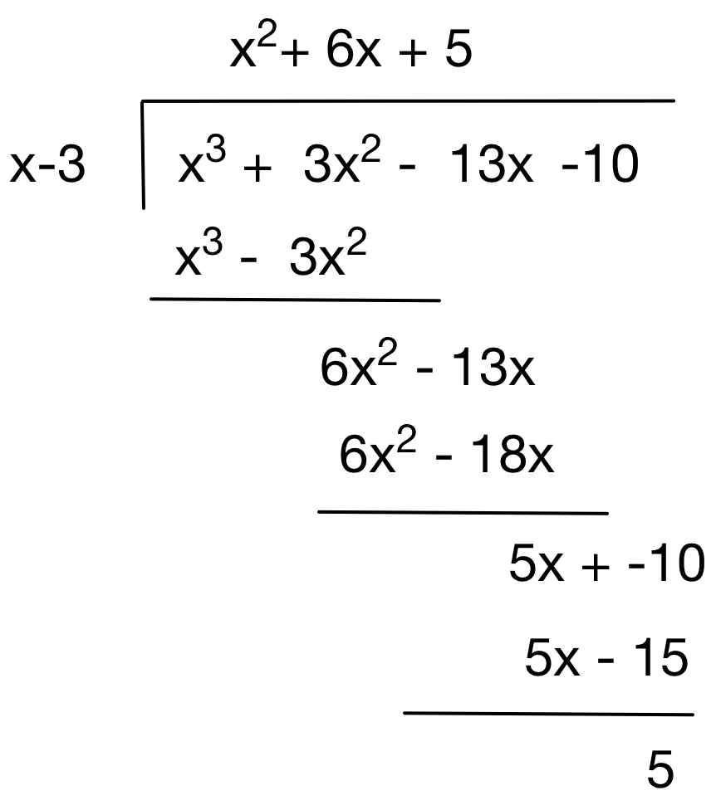

### Factor Theorem

If $f(x)$ is a polynomial and If $f\left(a\right)=0$ then $(x-a)$ is a factor. We can factorise a cubic equation by trying k=1,-1,2,-2 … until we find a value such that f(k) = 0. At this stage we know that x-k is a factor. Dividing by long division leaves us with a quadratic which we can factorise.

Similarly for higher degree polynomials. We just have to add more steps.

## Inequalities

The graph of an inequality is a region of the X-Y plane rather than a line or curve. Points above the graph of $y=f\left(x\right)$ are in the region described by $y>f(x)$ and the points below the graph of $y=f\left(x\right)$ and the points in the region described by $y<f(x)$

### Absolute value

If $\left|x\right|<a$ when a > 0 then $-a<x<a$

If $\left|x\right|>a$ when a > 0 then $-a>x>a$

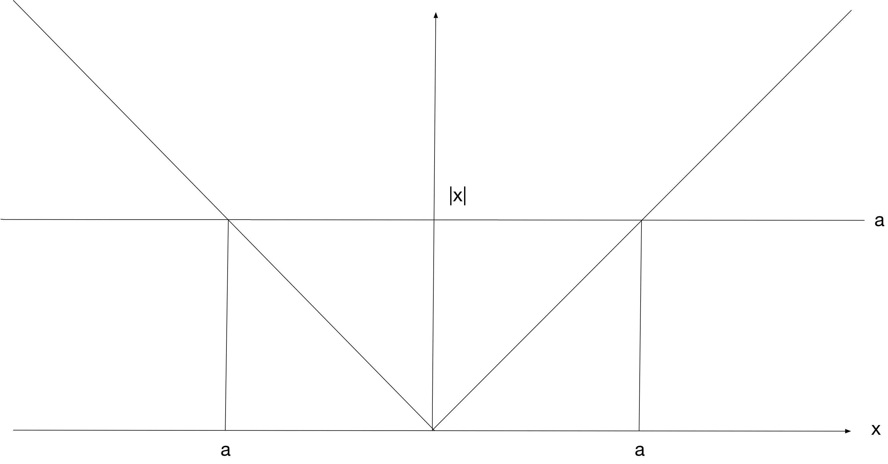

So then if $\left|x\right|<3$ then $-3<x<3$

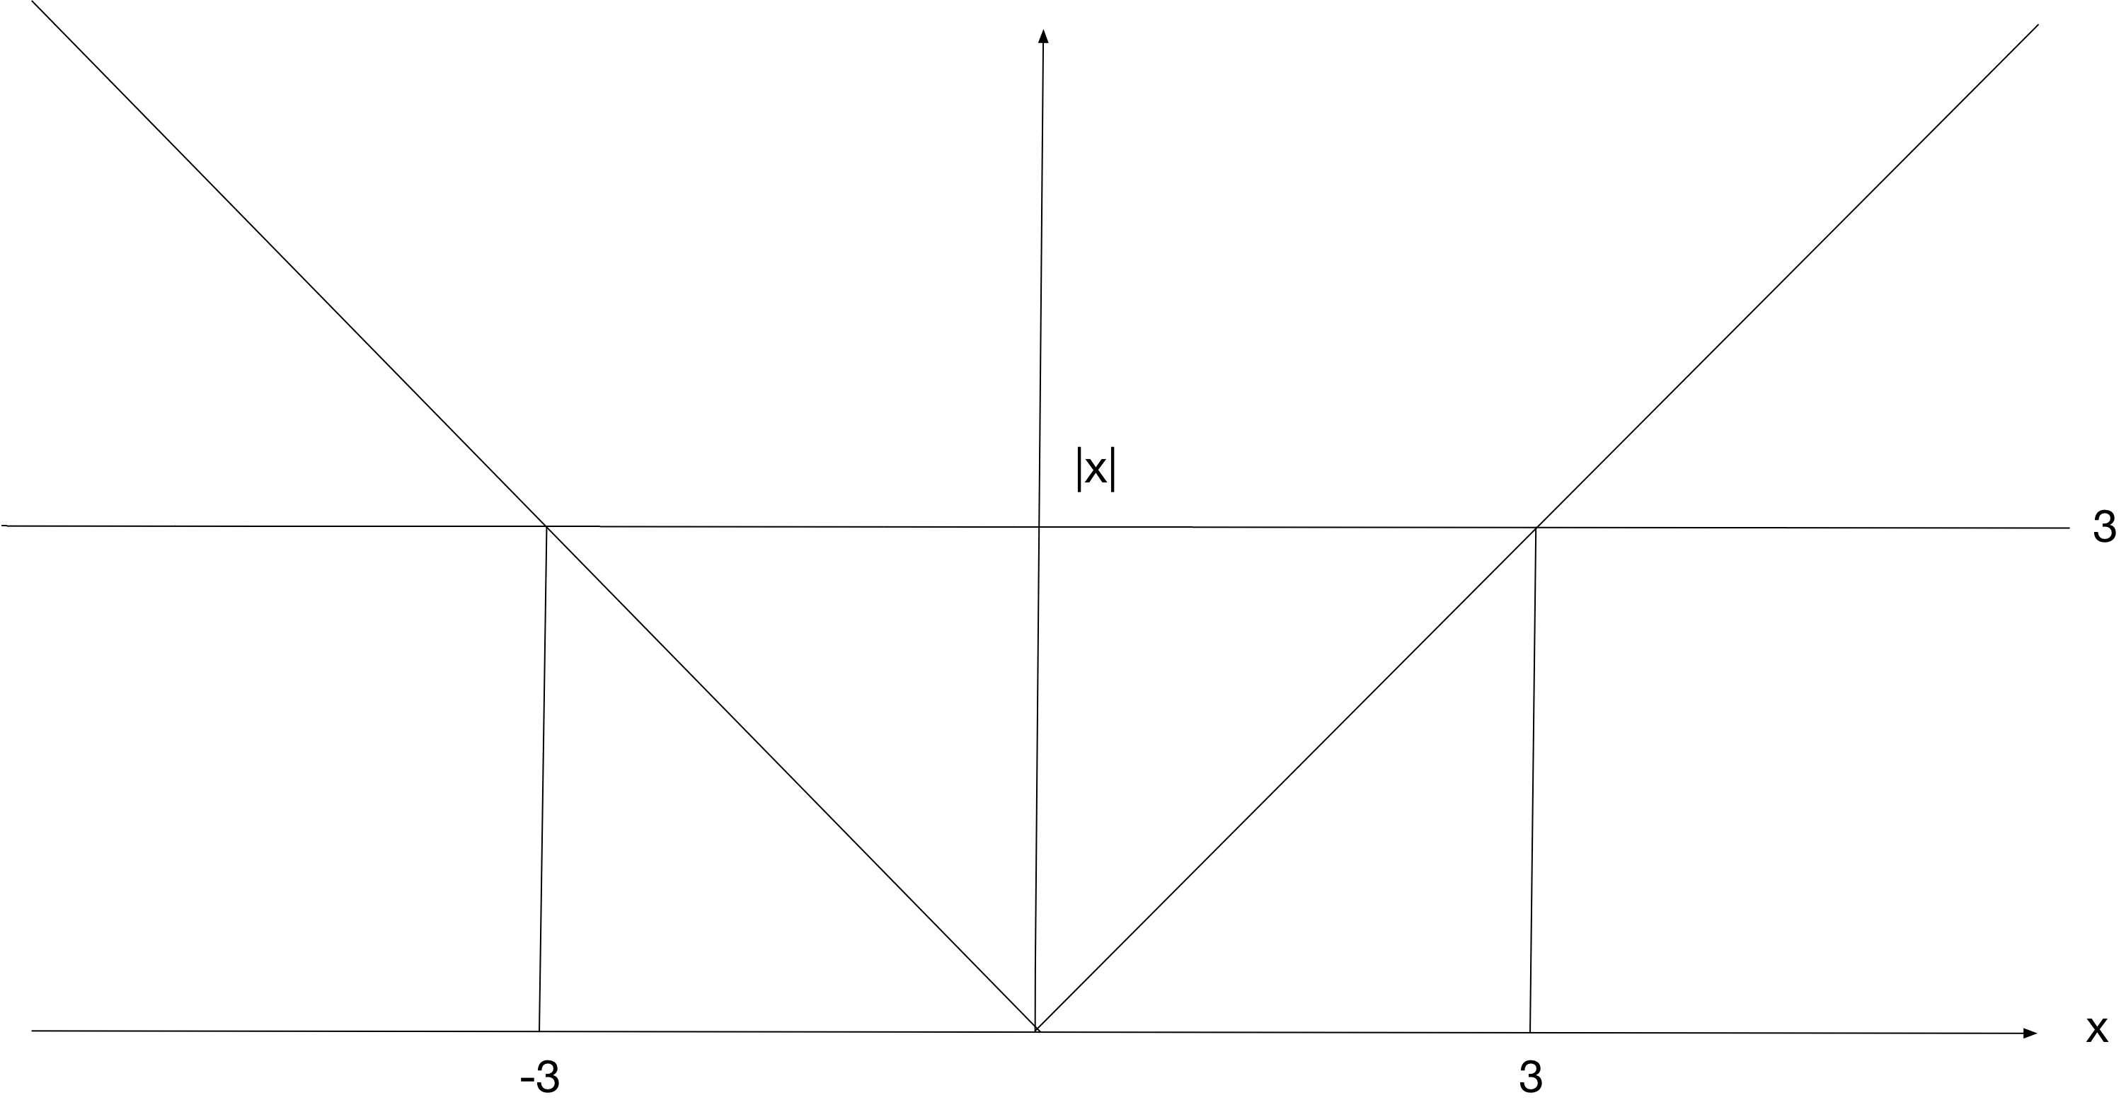

If $\left|x-1\right|<3$ then $-3<x-1<3$ and $-2<x<4$

More generally if $\left|x-c\right|<a$ then $-a<x-c<a$ and $-a+c<x<a+c$

Notice what happens when dividing by negative values.

$\left|7-2x\right|<9$

$-9< 7-2x<9$

$-16< -2x<2$

$-8< -x<1$

$-1< x<8$

Let us look at some greater than inequalities

$\left|x-1\right|>3$

$$-3>x-1>3$$

$$-2>x>4$$

Questions – Inequalities

Solve $\left|x-1\right|>3$

Solve $\left|7-2x\right|<9$

## Linear Equations

Questions – Linear Equations

Solve $\frac{x+2}{2}-\frac{x+5}{3}=\frac{2x-5}{4}+\frac{x+3}{6}$

LCM(2,3,4,6)=12. We multiply through by 12

$$\frac{12\left(x+2\right)}{2}-\frac{12\left(x+5\right)}{3}=\frac{12\left(2x-5\right)}{4}+\frac{12\left(x+3\right)}{6}$$

$$6\left(x+2\right)+4\left(x+5\right)=3\left(2x-5\right)+2\left(x+3\right)$$

Solve $\frac{4}{x-3}+\frac{2}{x}=\frac{6}{x-5}$

$LCM\left(\left(x-3\right),x\left(x-5\right)\right)=x\left(x-3\right)\left(x-5\right)$ Multiplying by LCM

$$\frac{4x\left(x-3\right)\left(x-5\right)}{x-3}+\frac{2x\left(x-3\right)\left(x-5\right)}{x}=\frac{6x\left(x-3\right)\left(x-5\right)}{x-5}$$

$$4x\left(x-5\right)+2\left(x-3\right)\left(x-5\right)=6x\left(x-3\right)$$

$$x=5/3$$

Solve $\frac{x-5}{x+5}+\frac{x-7}{x+7}=2$

X=-35/6

## Polynomial Equations

### Factorising Quadratic

Remember that if a quadratic will only have simple roots if $b^{2}-4ac$ is a perfect square. If the quadrative does not have simple roots we can find the roots in two ways

#### Completing the Square

$$x^{2}-6-4=0$$

$$x^{2}-6x=4$$

$${\left(x-3\right)}^{2}-9=4$$

$${\left(x-3\right)}^{2}=13$$

$$x-3x=±\sqrt{13}$$

$$x=3±\sqrt{13}$$

#### Formula

$$x=\frac{-b±\sqrt{b^{2}-4ac}}{2a}$$

### Factorising Cubic with at least one linear factor

The first step is to re-arrange the expression into nested form and use trial and error to find a linear factor

$${f\left(x\right)=2x}^{3}-11x^{2}+18x-8=0$$

$$f\left(x\right)=\left(\left(2x-11\right)x+18\right)x-8$$

Trial and error shows that $f\left(2\right)=0$ so $x=2$ is a root and $\left(x-2\right)$ is a linear factor. Now we divide ${f\left(x\right)=2x}^{3}-11x^{2}+18x-8$ by $\left(x-2\right)$

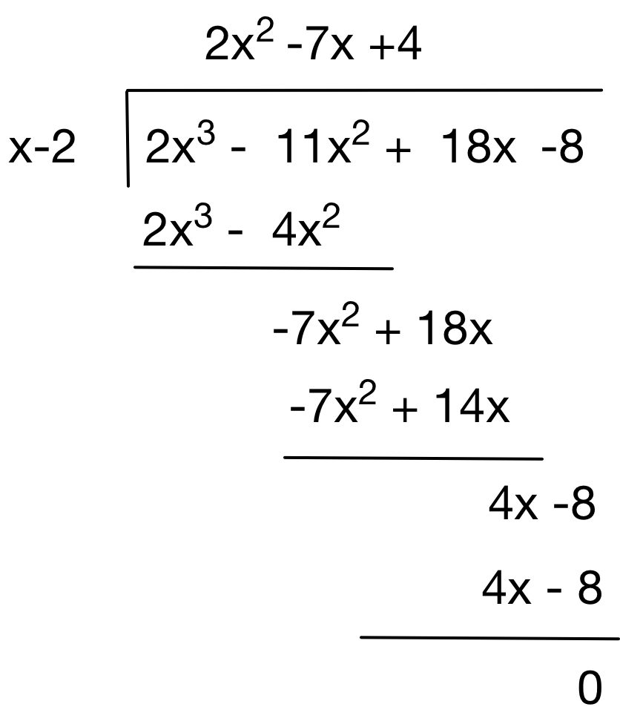

So we now have $\left(x-2\right)\left({2x}^{2}-7x+4\right)=0$

We can factorise the quadrative to get the remaining two (non simple) roots

### Factorising Quartic with at least two linear factors

The process is the same as solving a cubic with one linear factors. We find the first linear factor by arranging in nested form and using trial and error. We divide through to get the cubic quotient. We then use the nested form to find a linear root. We then divide the cubic by the second linear factor to get a quadratic which we can factorise using the quadratic formula

Questions – Polynomial Equations

Factoring Quadratic

Find the roots of $4x^{2}-16x+3=0$

$${4x}^{2}-16+3=0$$

$${4x}^{2}-16=-3$$

$${\left(2x-4\right)}^{2}-16=-3$$

$${\left(2x-4\right)}^{2}=13$$

$$2x-4=±\sqrt{13}$$

$$2x=4±\sqrt{13}$$

$$x=\frac{4±\sqrt{13}}{2}$$

## Partial Fractions

### Adding fractions

When we want to add and subtract fractions with different denominators, we first find the LCM of all the denominators

$$\frac{2}{5}-\frac{3}{4}+\frac{1}{2}$$

LCM(5,4,2)=20

Then we multiple numerator and denominator of each fraction by LCM/denominator

$$\frac{2}{5}×\left(\frac{{20}/5}{{20}/5}\right)-\frac{3}{4}×\left(\frac{{20}/4}{{20}/4}\right)+\frac{1}{2}×\left(\frac{{20}/4}{{20}/4}\right)$$

Giving us

$$\frac{2×4}{5×4}-\frac{3×5}{4×5}+\frac{1×10}{2×10}$$

Which is

$$\frac{8}{20}-\frac{15}{20}+\frac{10}{20}$$

### Adding algebraic fractions

Similarly, for algebraic fractions

$$\frac{2}{x-3}-\frac{4}{x-1}$$

$$LCM\left(\left(x-3\right),\left(x-1\right)\right)=(x-3)(x-1)$$

Then we multiple numerator and denominator of each fraction by LCM/denominator

$$\frac{2}{x-3}×\left(\frac{{(x-3)(x-1)}/{(x-3)}}{{(x-3)(x-1)}/{(x-3)}}\right)-\frac{4}{x-1}×\left(\frac{{(x-3)(x-1)}/{(x-1)}}{{(x-3)(x-1)}/{(x-1)}}\right)$$

$$\frac{2}{x-3}×\left(\frac{(x-1}{(x-1}\right)-\frac{4}{x-1}×\left(\frac{(x-3)}{(x-3)}\right)$$

$$\frac{2(x-1)}{(x-3)(x-1)}-\frac{4(x-3)}{(x-1)(x-3)}$$

$$\frac{10-2x}{(x-3)(x-1)}$$

So we have $$\frac{2}{x-3}-\frac{4}{x-1}=\frac{10-2x}{(x-3)(x-1)}$$

We say the two simple fractions $\frac{2}{x-3}$ and $\frac{4}{x-1}$ are partial fractions of $\frac{10-2x}{(x-3)(x-1)}$

### Reversing the process – partial fractions

Often, we want to reverse this process. Given a complex expression we want to back out the simpler partial fractions.

$$\frac{8x-28}{x^{2}-6x+8}$$

First we factorise the denominator

$$\frac{8x-28}{\left(x-2\right)\left(x-4\right)}$$

Assume each simple factor in the denominator produces a partial fraction in the result

$$\frac{8x-28}{\left(x-2\right)\left(x-4\right)}=\frac{A\left(x-4\right)}{\left(x-2\right)\left(x-4\right)}+\frac{B\left(x-2\right)}{\left(x-2\right)\left(x-4\right)}$$

Now $8x-28≡ A\left(x-4\right)+B\left(x-2\right)$

As an identity this is true for all values of x. We let x = 4 and then 2B=4, B=2

For this process to work the degree of the numerator must be less than the degree of the denominator.

### Degree of numerator not less than degree of denominator

In this case we need to divide through. Consider

$$\frac{10}{6}=1r4$$

Therefore $$10=1×6+4$$

And $$\frac{10}{6}=\frac{\left(1×6\right)+4}{6}=1+\frac{4}{6}$$

In general

$$dividend=\left(quotient×divisor\right)+remainder ∴$$

$$\frac{dividend}{divsor}=\frac{\left(quotient×divisor\right)+remainder}{divisor}∴$$

$$\frac{dividend}{divsor}=quotient+\frac{remainder}{divisor}$$

So looking at an algebraic example

$$\frac{x^{2}+3x-10}{x^{2}-2x-3}=1+\frac{5x-7}{x^{2}-2x-3}$$